Artificial Intelligence Assignment 1
- Describe the problem formulation steps in AI with examples.
Problem formulation is the process by which an agent defines the task it needs to solve. This involves specifying the initial state, goal state, actions, constraints, and the criteria for evaluating solutions.

Steps in Problem Formulation
- Define the Initial State: The initial state is the starting point of the agent.
Example: In a navigation problem, the initial state could be the agent's starting location on a map.
- Specify the Goal State: The goal state defines the desired outcome that the agent aims to achieve.
Example: For the navigation problem, the goal state is the destination location.

- Determine the Actions: Actions are the set of operations or moves that the agent can perform to transition from one state to another.
Example: In a robot navigation scenario, actions could include moving forward, turning left, or turning right.

- Establish the Transition Model: The transition model describes how the environment changes in response to the agent's actions.
Example: In a game, the transition model would include the rules that specify how the game state changes based on the player's moves.

- Set Constraints and Conditions: Constraints are the limitations or restrictions within which the agent must operate.
Example: For a delivery drone, constraints might include battery life, weight capacity, and no-fly zones.

- Criteria for Success: The criteria for success determine how the agent evaluates its progress and final solution.
Example: For a puzzle-solving agent, success criteria could be the completion of the puzzle within the shortest time or the fewest moves.

- What are the branches of AI? Explain in brief.

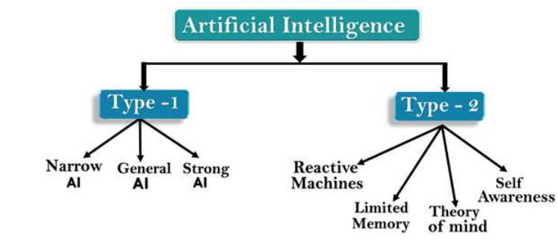

AI type-1:
Based on Capabilities
1. Weak AI or Narrow AI: Narrow AI is a type of AI which is able to perform a dedicated task with intelligence.
2. General AI: o General AI is a type of intelligence which could perform any intellectual task with efficiency like a human
3. Super AI: o Super AI is a level of Intelligence of Systems at which machines could surpass human intelligence, and can perform any task better than human with cognitive properties.

Artificial Intelligence type-2: Based on functionality
1. Reactive Machines o Purely reactive machines are the most basic types of Artificial Intelligence.
2. Limited Memory o Limited memory machines can store past experiences or some data for a short period of time.
3. Theory of Mind o Theory of Mind AI should understand the human emotions, people, beliefs, and be able to interact socially like humans.
4. Self-Awareness o Self-awareness AI is the future of Artificial Intelligence. These machines will be super intelligent, and will have their own consciousness, sentiments, and self-awareness.

- Find a path between nodes A and G using BFS for the given tree.
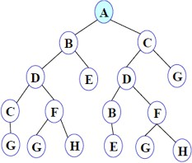
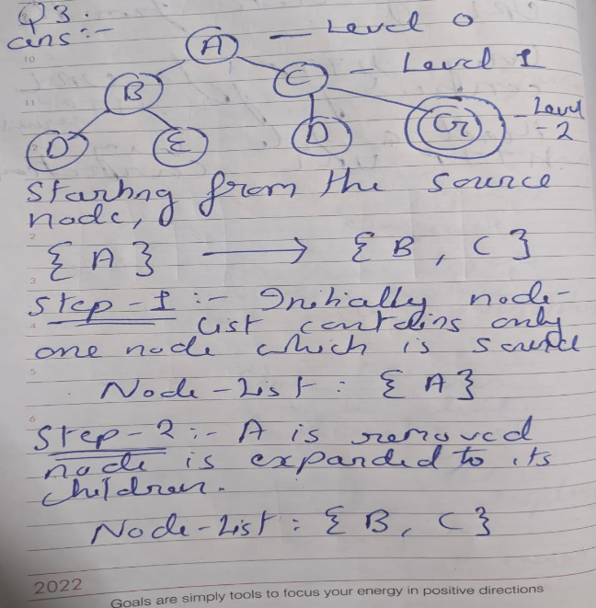

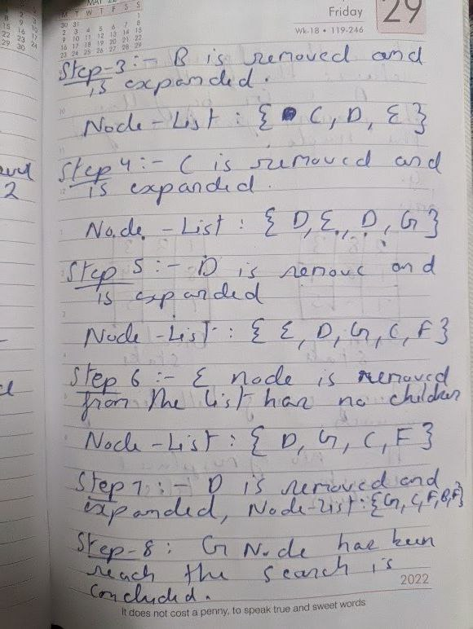
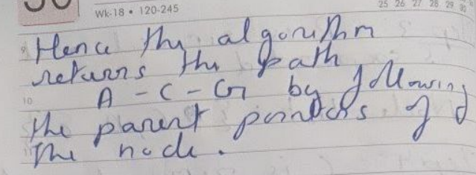

- Solve the given 8-puzzle problem.

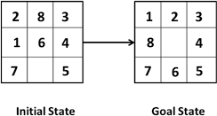

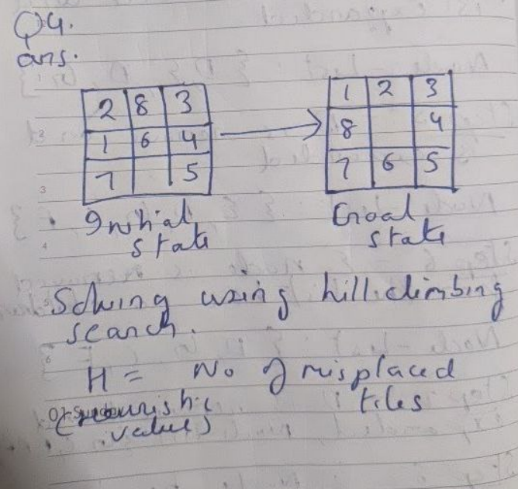
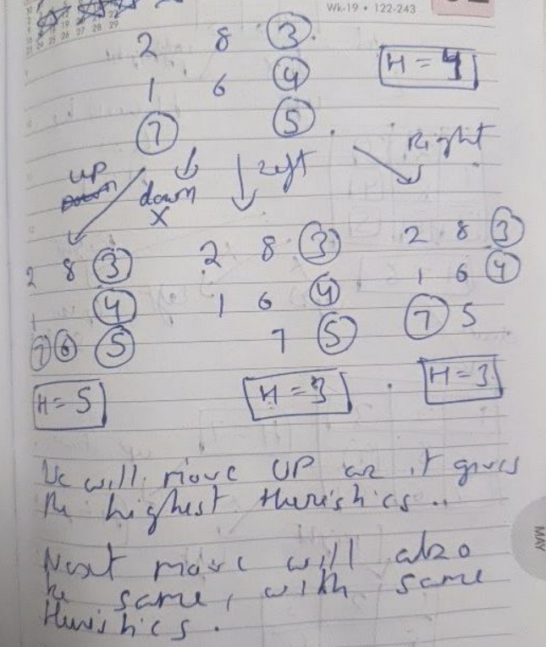

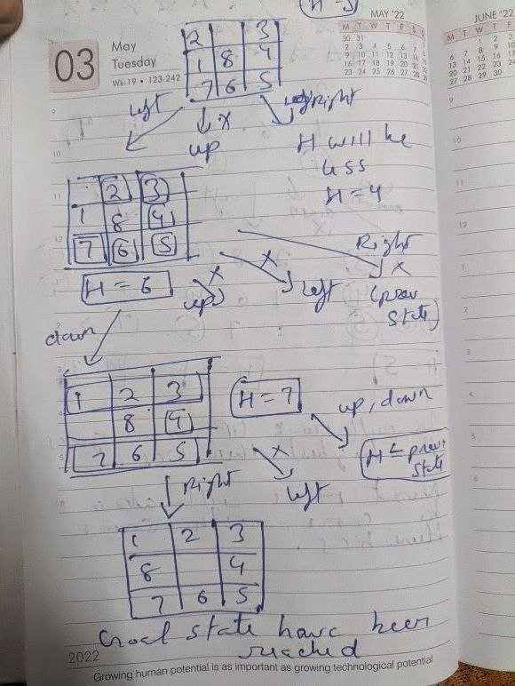

- What do you mean by Blind search? Explain different types of Blind search with an example.
Uninformed search in also called a blind search because it is a class of general-purpose search algorithms which operates in brute force-way. Types of blind search are as follows:-
1. Breadth-first Search
2. Depth-first Search
3. Depth-limited Search
4. Iterative deepening depth-first search 5. Uniform Cost Search 6. Means End Analysis

Example:-
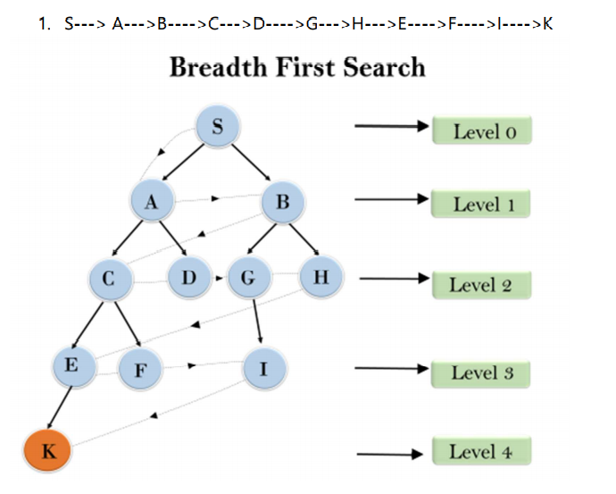

- Discuss various steps in problem-solving techniques.

Steps problem-solving in AI: The problem of AI is directly associated with the nature of humans and their activities. So we need a number of finite steps to solve a problem which makes human easy works. These are the following steps which require to solve a problem :

• Problem definition: Detailed specification of inputs and acceptable system solutions.
• Problem analysis: Analyse the problem thoroughly.
• Knowledge Representation: collect detailed information about the problem and define all possible techniques.
• Problem-solving: Selection of best techniques.

- Explain the concept of Production Systems in AI in detail.

A production system is based on a set of rules about behavior. These rules are a basic representation found helpful in expert systems, automated planning, and action selection.

The major components of the Production System in Artificial Intelligence are:
• Global Database: The global database is the central data structure used by the production system in Artificial Intelligence.

• Set of Production Rules: The production rules operate on the global database. Each rule usually has a precondition that is either satisfied or not by the global database.

• A Control System: The control system then chooses which applicable rule should be applied and ceases computation when a termination condition on the database is satisfied.

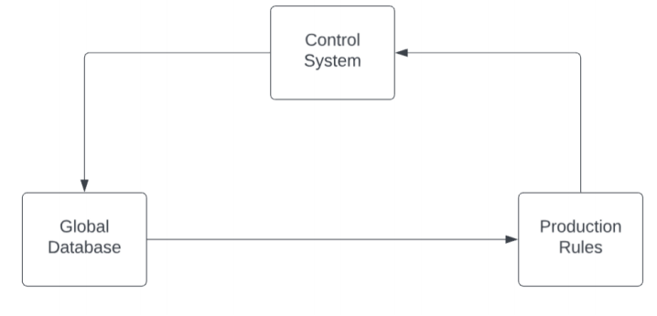

- What do you mean by heuristic and heuristic search techniques?
Heuristics are problem-solving techniques or strategies used to make decisions, find solutions, or discover approximate answers more efficiently when facing complex problems.
The informed search algorithm is more useful for large search space. Informed search algorithm uses the idea of heuristic, so it is also called Heuristic search.
Some of heuristic search techniques are as follows:-
Best first search, A* Search Algorithm, AO* algorithm

- What is the need for the evaluation function?

In AI, an evaluation function plays a critical role in guiding search algorithms, especially when the search space is large or the problem is complex. The evaluation function estimates the "goodness" or quality of a state, helping the search algorithm decide which path to take next.

The evaluation function is needed to:
- Direct the search towards more promising states or actions.
- Evaluate solution quality to determine the best course of action or state.
- Increase efficiency by reducing unnecessary exploration of less optimal states.
- Support heuristics and optimization in complex or large search spaces.
Used in Best fit, A* search etc.

- What do you mean by problem reduction? Explain with the help of an AND-OR graph.

The AO* method divides any given difficult problem into a smaller group of problems that are then resolved using the AND-OR graph concept. AND OR graphs are specialized graphs that are used in problems that can be divided into smaller problems.

This decomposition or reduction generates arcs that we call AND arcs. One AND arc may point to any numbers of successor nodes. All of which must then be solved in order for the arc to point solution.

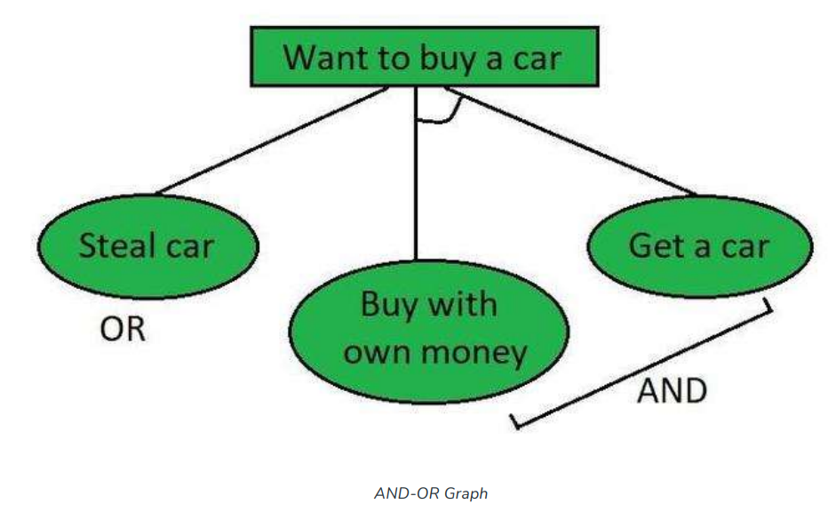

In the above figure, the buying of a car may be broken down into smaller problems or tasks that can be accomplished to achieve the main goal in the above figure, which is an example of a simple AND-OR graph.

- Find the path from P to S from the following graph by using the best-first search algorithm.

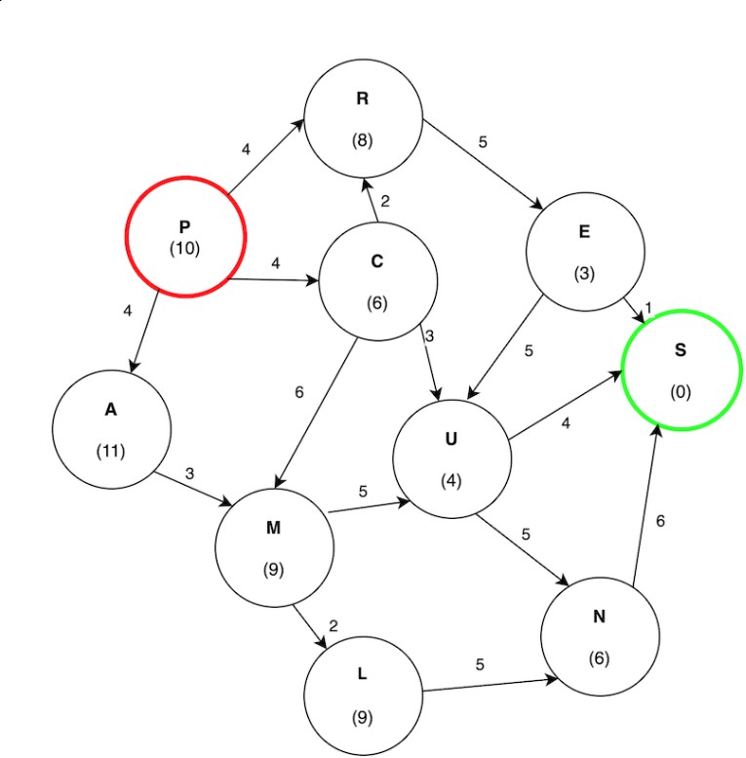

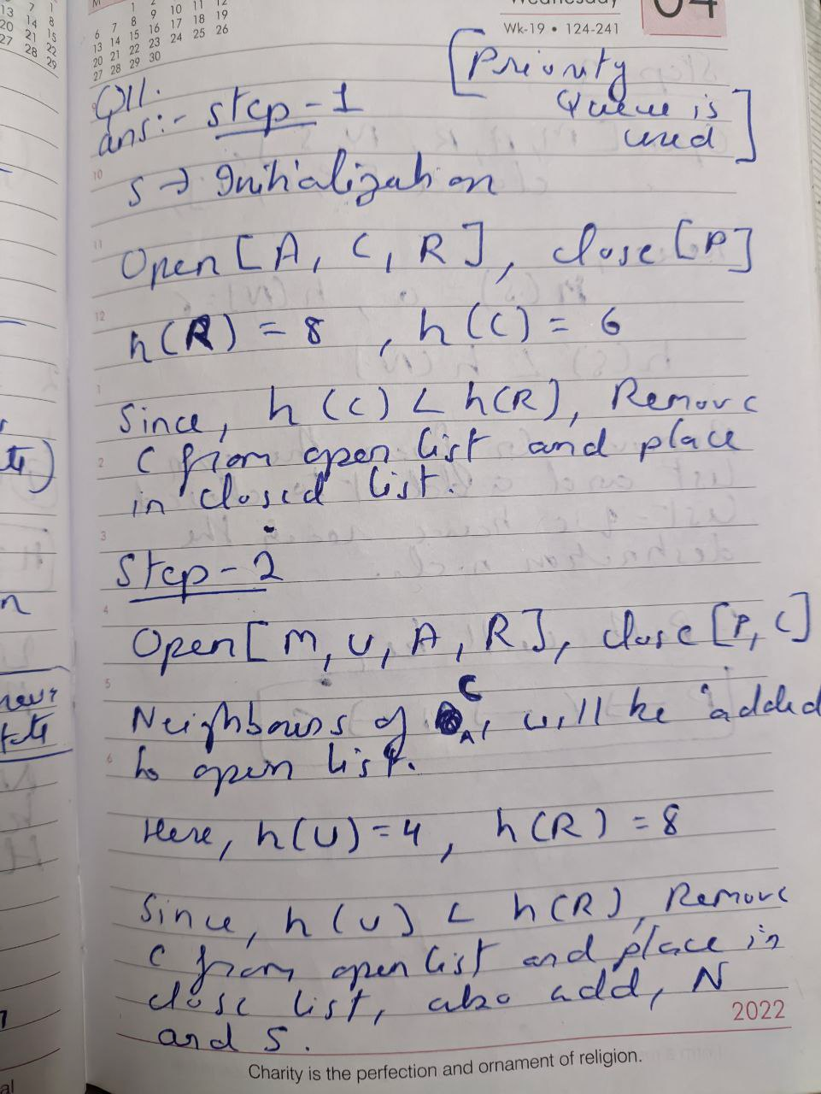
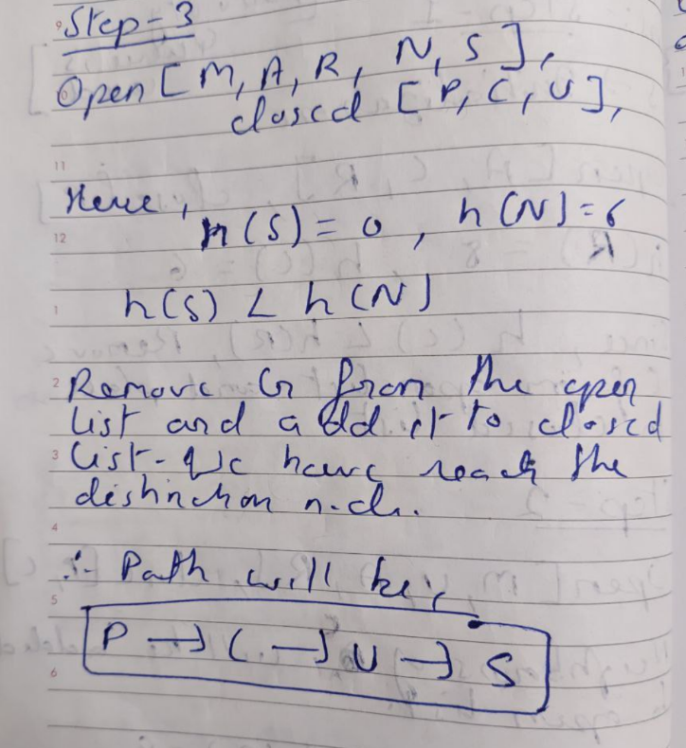

- What is a state-space diagram for the Hill-climbing algorithm? Explain all the regions in the state-space diagram of the Hill-climbing algorithm.

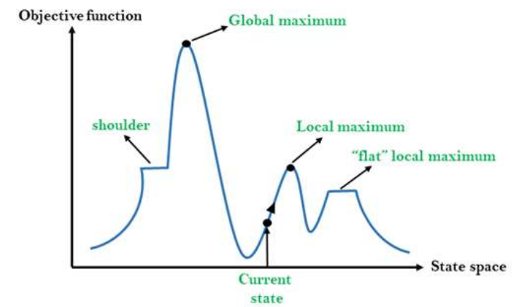

Local Maximum: Local maximum is a state which is better than its neighbor states, but there is also another state which is higher than it.

Global Maximum: Global maximum is the best possible state of state space landscape. It has the highest value of objective function.

Current state: It is a state in a landscape diagram where an agent is currently present.
Flat local maximum: It is a flat space in the landscape where all the neighbor states of current states have the same value.

Shoulder: It is a plateau region which has an uphill edge.

- Consider the following graph. The numbers written on nodes represent the heuristic value.
Find the most cost-effective path to reach from start state A to final state J using A* algorithm.

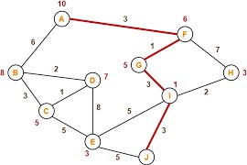

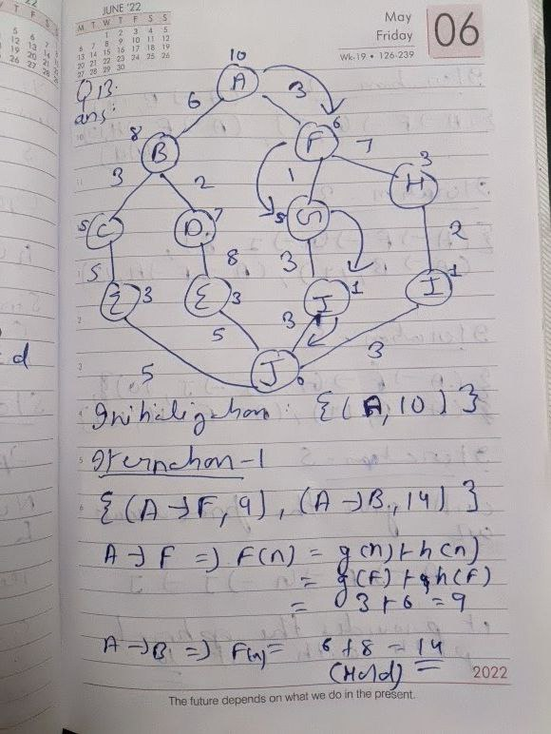
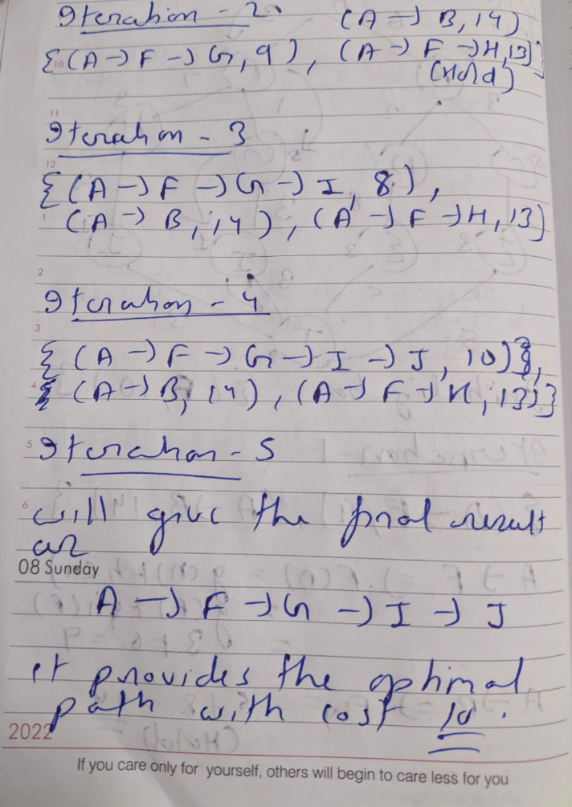
- Find the path to reach goal node G from A by using the Breadth First Search algorithm on the following graph.

Same question as 3, write the answer from 3rd question.
- Find the final solution path by using the Best First Search on following graph.
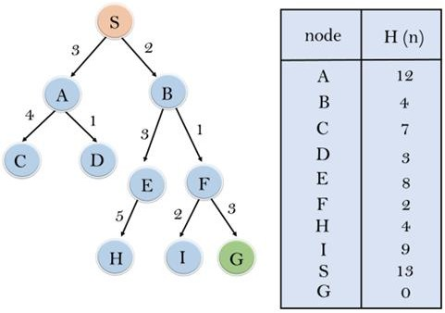
Expand the nodes of S and put in the CLOSED list
Initialization: Open [A, B], Closed [S]
Iteration 1: Open [A], Closed [S, B]
Iteration 2: Open [E, F, A], Closed [S, B] :
Open [E, A], Closed [S, B, F]
Iteration 3: Open [I, G, E, A], Closed [S, B, F] :
Open [I, E, A], Closed [S, B, F, G]
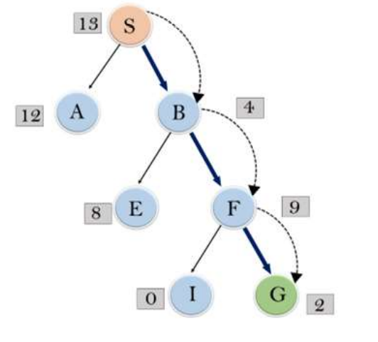
Hence the final solution path will be: S----> B----->F----> G

